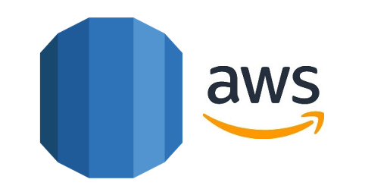

Build Your DB Server and Interact With Your DB Using an App

AWS Lab 5

Evan Choi | Cisco CCNP | 4/27/2022

**Background Information**

Amazon Relational Database Service (RDS) makes a relational database in the cloud very easy to set up, operate and scale. It supports a wide array of database engines that can help store and organize data. It can also help with tasks like data migration, backup, recovery and patching.

**Configuration Steps**

Accessing the AWS Management Console

1. Click the start lab button until you get the **“Lab status ready”** message



1. Open the AWS Management Console by clicking the AWS button



Creating a Security Group for the RDS DB Instance

1. Click the **Services** box, then click **All Servers**, and clock on **VPC**

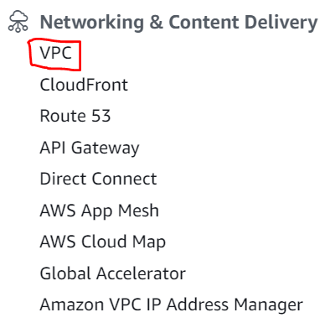

1. On the left menu, click **Security Groups**

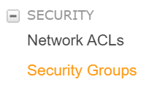

1. Click the orange **Create security group** button and configure the following:

**Security group name:** DB Security Group

**Description:** Permit access from Web Security Group

**VPC:** Lab VPC

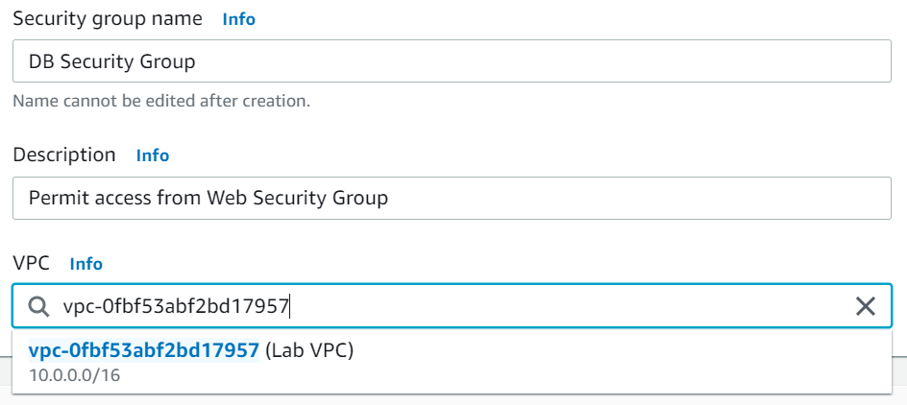

1. In the **Inbound rules** section, click the **Add rule** button. Configure the following:

**Type:** MySQL/Aurora (3306)

**CIDR, IP, Security Group or Prefix List:** Type sg and click the one that says **Web Security Group**

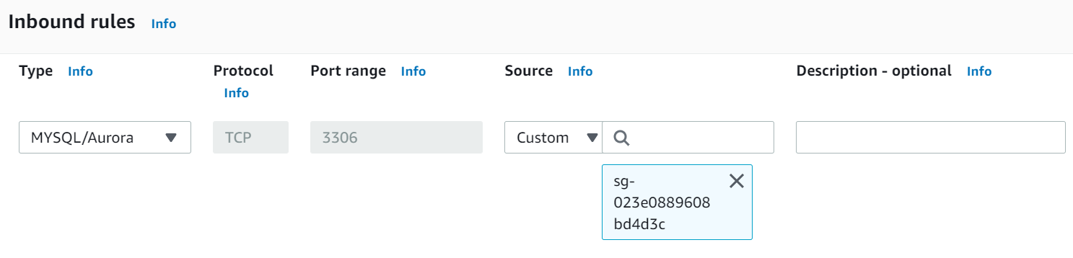

1. Scroll down and click the orange **Create security group** button

Creating a DB Subnet Group

1. In the top left, click the **Services** menu and scroll until you find **RDS.** Click it.

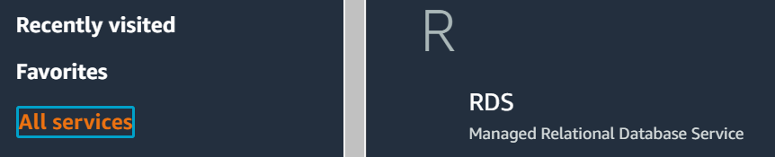

1. On the left menu, click **Subnet groups**
2. Click the **Create DB Subnet Group** button and configure the following:

**Name:** DB-Subnet-Group

**Description:** DB Subnet Group

**VPC:** Lab VPC

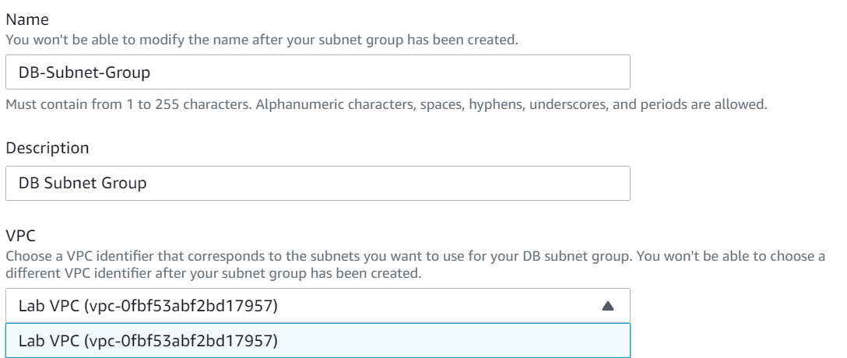

1. Scroll to the **Add Subnets** section
2. Click the **Availability Zones** drop-down and select the first two zones: **us-east-1a** and **us-east-1b**

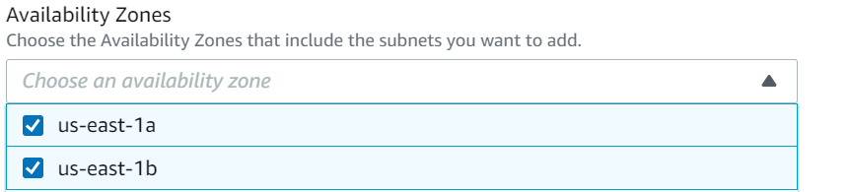

1. Click the **Subnets** drop-down and select the subnets associated with the CIDR ranges, which are **10.0.1.0/24** and **10.0.3.0/24.**

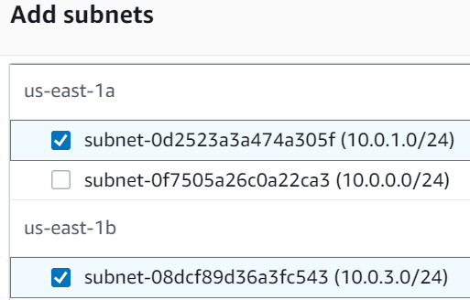

1. Click the orange **Create** button

Creating an Amazon RDS DB Instance

1. On the left menu **Databases,** and click the orange **Create database** button
2. Make sure that **MySQL** is selected

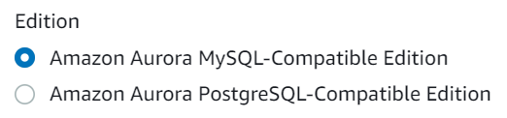

1. Scroll to the **Settings** section and configure the following:

**DB cluster identifier:** lab-db

**Master username:** main

**Master password:** lab-password

**Confirm password:** lab-password

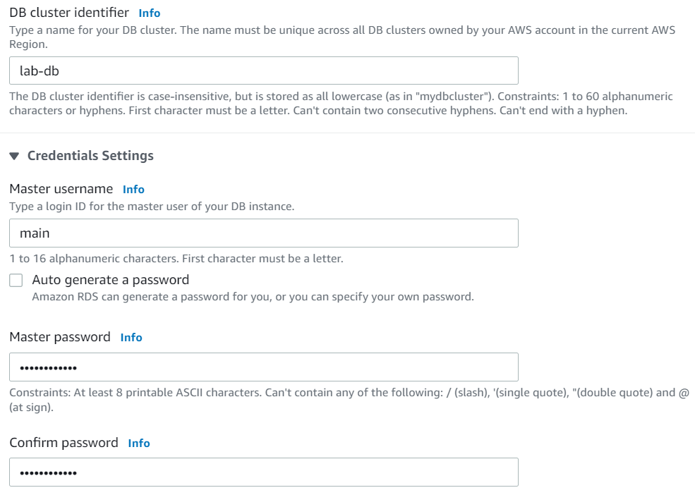

1. Scroll to the **Instance configuration** section and under **DB instance class,** select **Burstable classes (includes t classes)** and select **db.t3.small.**

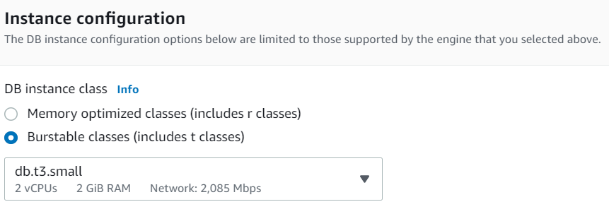

1. Under the **Connectivity** section click the **VPC** drop-down and select **Lab VPC**

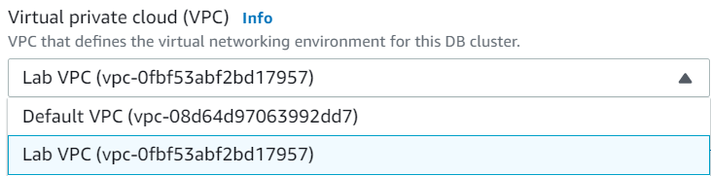

1. Click the **Existing VPC security groups** drop-down and select **DB Security Group** and click the X next to **default**

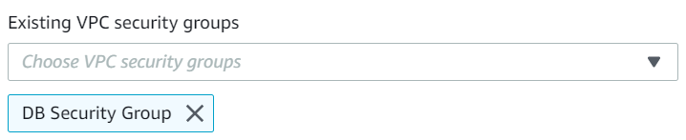

1. Scroll until you find the **Additional configuration** section and do the following:

Under **Initial database name:** lab

Uncheck **Copy tags to snapshots**

Uncheck **Enable encryption**

Uncheck **Enable Enhanced monitoring**

1. Click the orange **Create database** button
2. Click the **lab-db** link. It will take a couple minutes for the database to become available
3. Once **Info** changes to **Modifying** or **Available,** find the **Connectivity & security** section and copy the **Endpoint** field

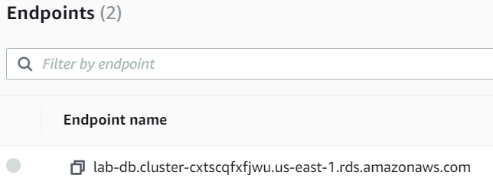

1. Paste this somewhere so you can use it later in the lab

Interacting with Your Database

1. On the instructions page, click the **Details** drop-down and click **Show**

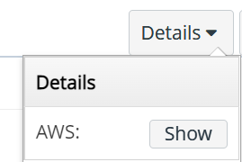

1. Copy the **WebServer** IP address and enter it into a web browser



1. The following image should appear. Click the RDS link at the top of the page

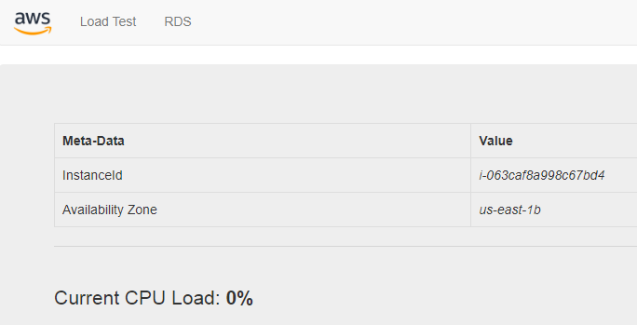

1. Configure the following:

**Endpoint:** Paste the endpoint from step 25

**Database:** lab

**Username:** main

**Password:** lab-password

Click the **Submit** button

1. A message should show up saying that the application is running a command that will copy information to the database. After a little bit, it should display an **Address Book**
2. To test the web application, **add, edit,** and **remove contacts**

You have finished this lab!

1. Click the **End Lab** button and select the blue **Yes** button.



**Conclusion**

In this lab you will launch an Amazon RDS Database instance that’s highly available, configure a Database instance to allow connections from a web server, and open a web application so you can interact with your database.